Submitting assignments to Moodle
- Find the assignment submission point your need on Moodle. It will have an icon like the one shown in Figure 1 below and a title describing the assignment

Figure 1: Assignment icon
- Click on the assignment link. The assignment submission page is displayed which contains further information about the assignment you are submitting (See Figure 2).
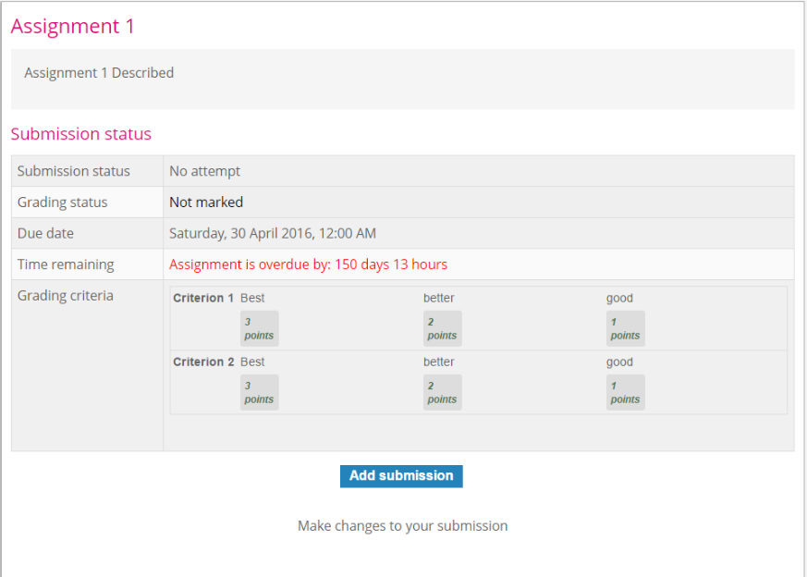

Figure 2: Assignment Description
- Click on the Add submission button to start the process of uploading and submitting your assignment.
- If this is the first time you are submitting work to Turnitin you will be prompted to accept the Turnitin End User Licence Agreement (EULA) (Figure 3). You will only need to do this once. Unless you agree your work will not be submitted through Turnitin.
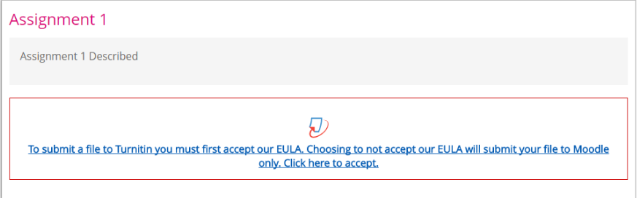
Figure 3: Turnitin End User Licence Agreement (EULA)
- Review the Turnitin EULA and click the I agree button (Figure 4) if you agree to the EULA.
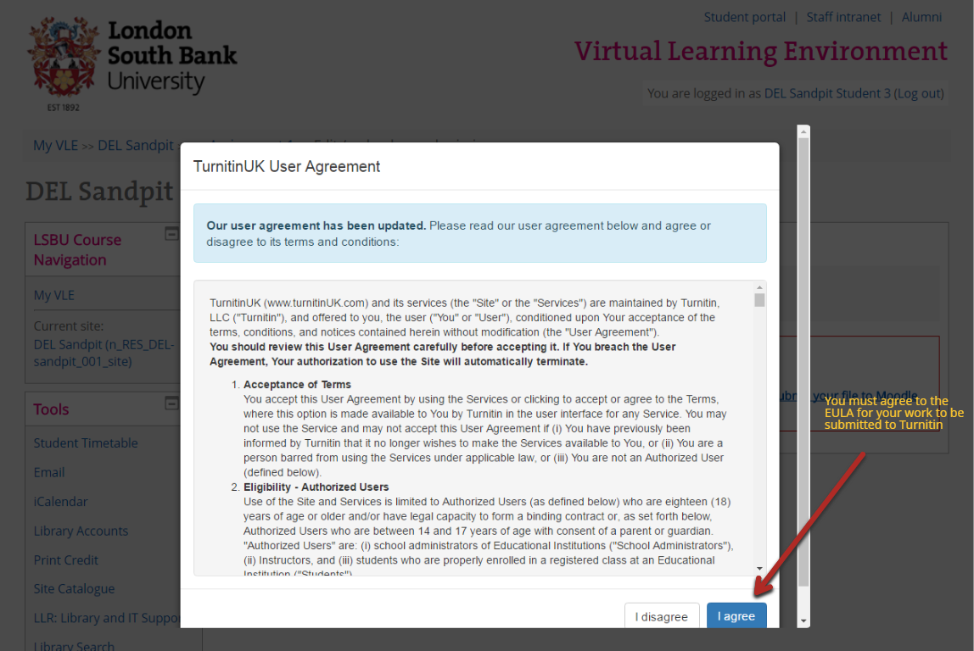
Figure 4: Turnitin EULA
- Upload your assignment either by browsing to assignment file on your computer or dragging and dropping it into the appropriate area on the Assignment upload screen. (Figure 5)
- Click the Save changes button to start the upload process. NOTE: Clicking Save changes DOES NOT submit your assignment for marking, you MUST complete the rest of the steps in this process
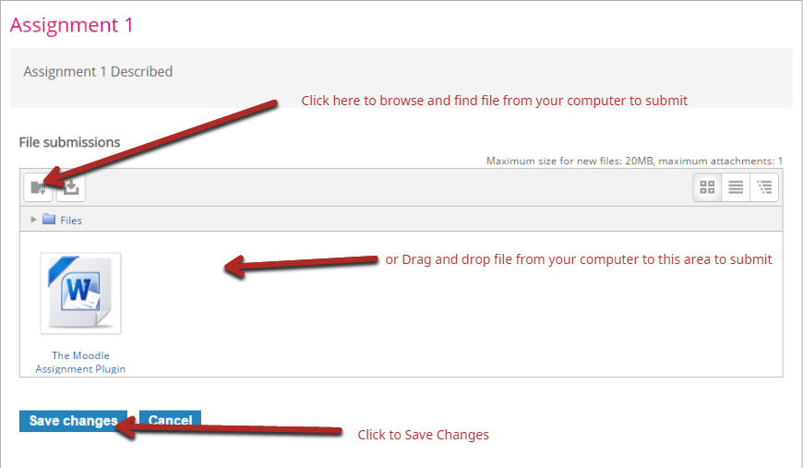
Figure 5: Assignment upload screen
- Once saved you are returned to the Assignment submission screen (Figure 6) which shows the file selected for submission
- At this stage you have two options (see buttons in screenshot below):
- Edit / upload my submission – this option allows you to go back and edit / change the file you have selected to upload
- Hand in my submission – This option commits your file for submission to marking
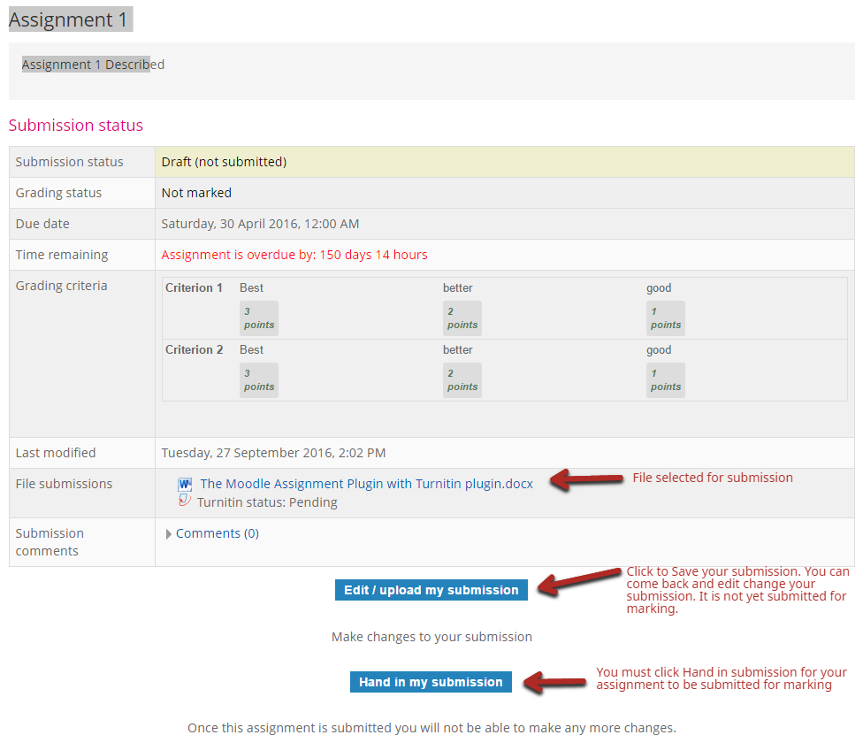
Figure 6: Assignment submission screen
- Once you have clicked Hand in my submission in the previous step you are required to accept the declaration that the work being submitted is your own (Figure 7). The assignment will not be accepted as submitted unless you accept this declaration.
- Click the checkbox to accept the declaration
- Click Continue to submit the assignment.
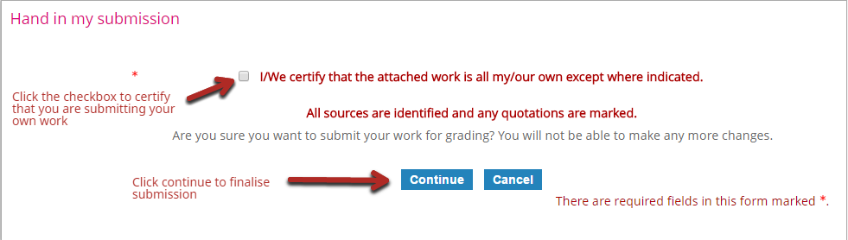
Figure 7: Assignment submission declaration
- Once you have accepted the declaration, the Assignment Submission screen (Figure 8) is shown indicating that the assignment has been submitted for grading and shows when it was submitted.
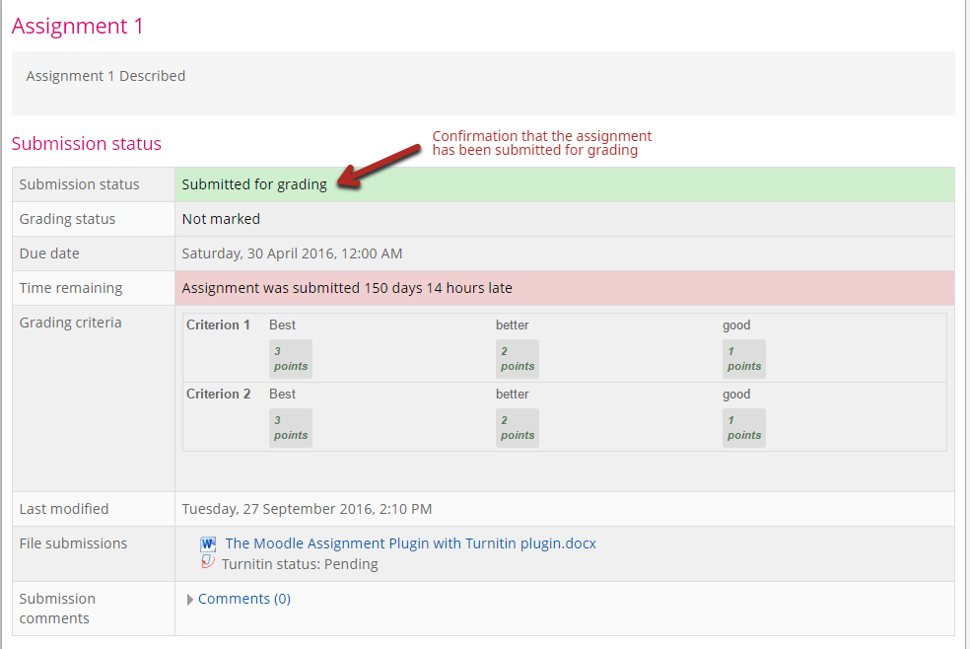
Figure 8: Assignment Submission screen

Viewing / Accessing the Turnitin originality report
The following steps will allow you to view the Turnitin Originality Report if it has been made available for students to view.
- Find the assignment submission point your need on Moodle. It will have an icon like the one shown in Figure 1.

Figure 1: Assignment icon
- Click on the assignment link. The assignment submission page is displayed which contains further information about the assignment you are submitting (See Figure 2).
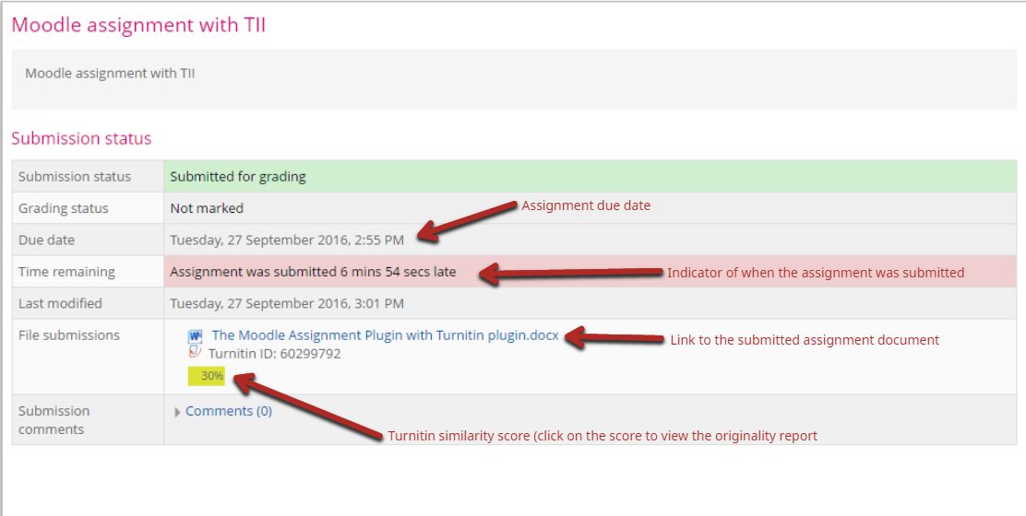
Figure 2 Assignment Submission Screen
- Click on the Turnitin similarity score to view your Turnitin Originality Report (see Figure 2).

